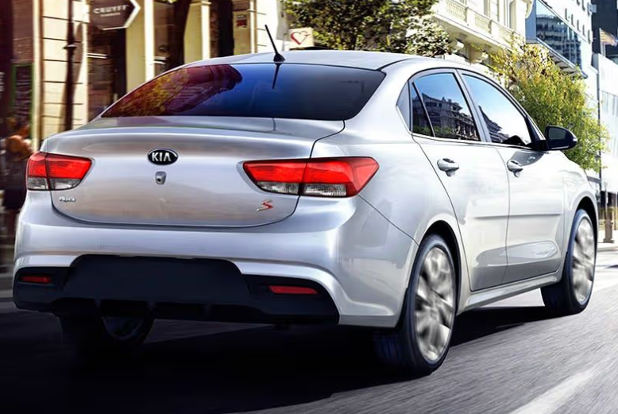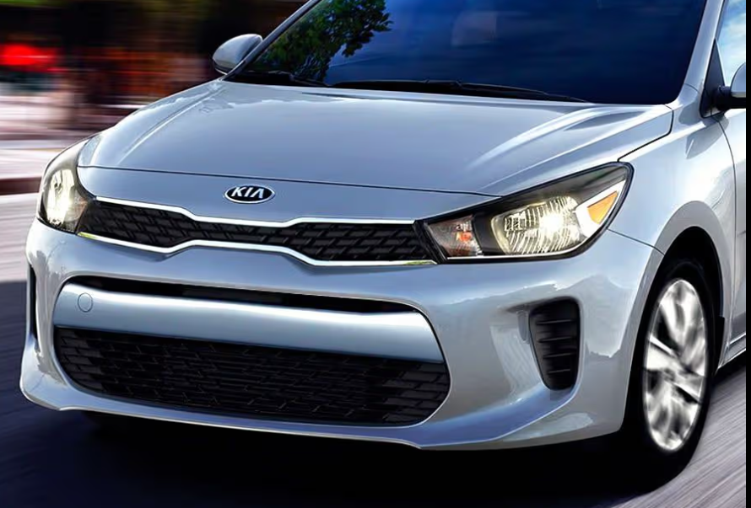

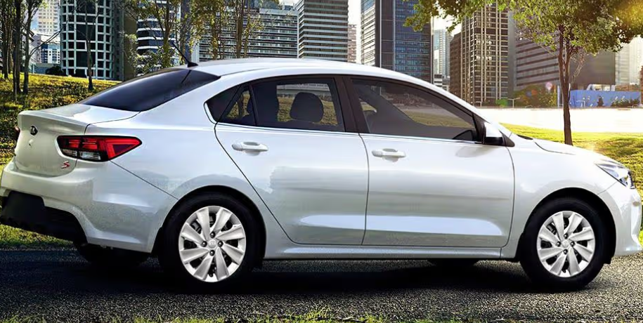

**Main Specifications** for the **2025 Kia Rio**

### 🔧 Powertrain & Performance

* **Engine Options**:
  + 1.2 L MPI petrol – ~84 hp, ~122–133 Nm torque, mated to 5‑speed manual or 4/6‑speed automatic
  + 1.0 L T‑GDi mild-hybrid (48 V) – ~100–118 hp, ~172–200 Nm torque, paired with 6‑speed manual or 7‑speed DCT (GT‑Line)
* **Drivetrain**: Front-wheel drive
* **0–100 km/h (0–62 mph)**:
  + ~12–13 s (1.2 L MPI)
  + ~9–10 s (1.0 T-GDi)

**⛽ Fuel Economy**

* **1.2 L MPI**: ~5.4 L/100 km (~46 mpg) – combined WLTP
* **1.0 T-GDi mild-hybrid**: Likely slightly higher efficiency, though exact figures vary (~5 L/100 km expected)

**📏 Dimensions & Capacity**

* **Length**: ≈ 4,065 mm
* **Width**: ≈ 1,725 mm
* **Height**: ≈ 1,450 mm
* **Wheelbase**: 2,580 mm
* **Curb weight**: ~1,130–1,255 kg (varies by engine/trim)
* **Fuel tank**: 45 L
* **Boot space**:
  + ~325 L (hatchback) to ~388 L in some versions

**🛋 Interior & Technology**

* Up to **10.25″ touchscreen infotainment** with wireless Apple CarPlay & Android Auto
* Optional **4.2″ digital instrument cluster**
* **Kia Connect services** (remote access, diagnostics, e‑SOS) on higher trims

**🛡 Safety & Driver-Assist**

* Standard: ABS, ESC, dual front airbags, ISOFIX
* Available: AEB (autonomous emergency braking), lane-keep assist, blind-spot monitoring, rear parking sensors/camera

**🏁 Chassis & Handling**

* **Suspension**: Front MacPherson strut; rear torsion-beam
* **Wheels**: 15″ alloys standard; optional dual-clutch DCT on GT‑Line variant
* **Steering**: Electric rack‑and‑pinion with ~5.1 m turning radius

**✅ Quick Specs Table**

| **Spec** | **1.2 L MPI (Base)** | **1.0 L T‑GDi M‑Hybrid (GT‑Line)** |
| --- | --- | --- |
| Power | ~84 hp / 122–133 Nm | 100–118 hp / 172–200 Nm |
| Transmission | 5‑MT / 4‑AT | 6‑MT or 7‑Speed DCT |
| 0–100 km/h | ~12–13 s | ~9–10 s |
| Fuel Efficiency | ~5.4 L/100 km | ~5 L/100 km (est.) |
| Dimensions (L×W×H) | 4,065×1,725×1,450 mm | Same |
| Wheelbase | 2,580 mm | Same |
| Boot Space | ~325 L | ~388 L (approx.) |
| Infotainment | Up to 10.25″ screen | Same |
| Safety Features | ESC, ABS, airbags, ISOFIX | + AEB, LKA, BSM, sensors |

**Bottom line**: The 2025 Kia Rio offers a refined B-segment package with a choice between a simple and reliable 1.2 L engine or a more advanced and efficient 1.0 L mild-hybrid turbo for added performance and fuel economy. It comes loaded with modern tech and strong safety features.